Introduction

This guide is aimed at someone who fancies having a try at making themselves an English longbow but who has no idea how to go about it (even if you have no woodworking experience at all)
i.e. In exactly the same position I was in myself not so long ago

I should point out that I have no training in the subject and most of what I am passing on here is either what people on forums have kindly passed on to me or I have figured out myself through trial and error.
I strongly suspect much of what I say here will cause a real bowyer to laugh out loud, but what I can say is that using these methods I have made several bows ranging from 45lb at 28” to 160lb at 32” at a maximum cost of £40.

Although the guide takes you through making a self bow with chased growth ring, I would actually recommend that for a first bow you consider making a laminate or a self bow turned through 90 degrees (both explained later in this guide) as they are very much easier to make
So if you want to make yourself a working bow as cheaply and simply as possible then this is the guide for you.
If you want to learn the traditional techniques then this may not be for you? but you could consider attending a course
like the ones run by www.diyarchery.co.uk or www.tradlongbows.co.uk

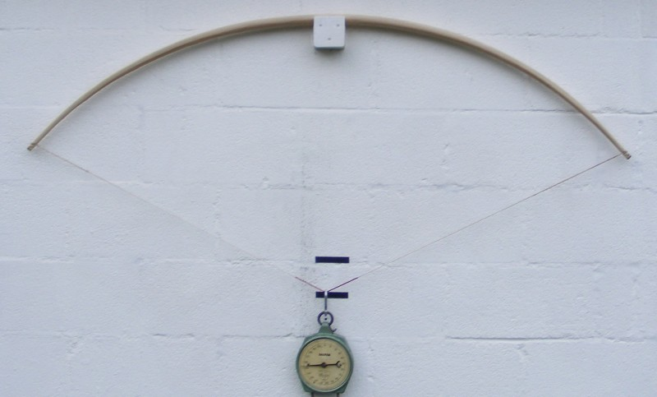
All the longbows I have made are the traditional medieval style of English longbow
i.e. Full compass, no handle, no arrow shelf etc.

check www.alanesq.com for latest version of this document and for info on the author
As and when people inform me of mistakes etc. I will update this guide so hopefully it will improve as time goes on.
Anyone who has extra info/advice please pass on to me and I will add your info to the guide.

I created this guide in the hope it is of help to others who wish to have a try at making a longbow and to return all the help I have received myself from others.
If you have anything to add (or corrections) please email me at alan@alanesq.com
If you do feel this has been worthwhile please consider donating towards the costs of hosting it via Paypal to alan@alanesq.com
CONTENTS

1 What you will need (3)

2 Buying some wood (4 - 5)

3 Making a start – Ring chasing (6)

4 Marking out the sides (7)

5 Marking out the belly (8)

6 Shaping the bow (9)

7 Temp nocks and string (10)

8 Tillering (11 - 14)

9 Finishing (15)

10 Misc adnl tillering info (16)

11 Bow dimensions (17)

12 Making heavier than 110lb at 32” bows (18)

13 Laminates (19 - 22)

14 Repairs (23)

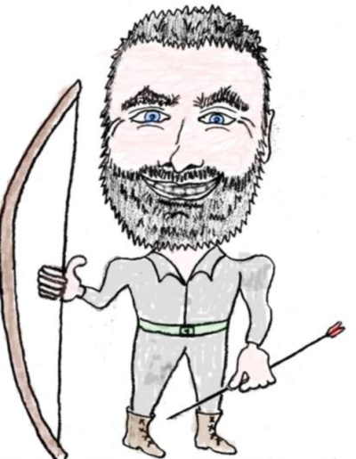
15 Links (24)
1. What you will need

What I think was my greatest discovery (and the thing which will I think upset most real bowyers at the very idea of using) is the angle grinder with sanding attachment.
I spent some time trying to use a spoke shave and then a draw knife but both these have the big disadvantage that they require a lot of patience and skill to use (both of which I didn't have) and I was very close to giving up as it seemed an impossible task. Then out of sheer desperation I tried my angle grinder and it was a revelation; what had seemed an impossible task was suddenly transformed in to a very simple and quick job :-)
The angle grinder and sanding disk is just like a normal rotary sander apart from it spins much faster, with it you can remove very small amounts of wood or surprisingly large amounts depending how hard you press and there is never any worry of ripping chunks out of the wood as there is with the normal woodworking tools.
You can buy angle grinders very cheaply these days and Machine Mart sell the sanding disk kit for around £12 or B&Q sell them
Safety warning
The angle grinder will happily sand off your skin as well as wood so some sturdy gloves are a very good idea. It also creates lots of very fine dust which is not at all good for you so a good dust mask is required which filters fine dust (I believe one suitable for working with MDF is what you require) and some eye protection.

The one hand tool I do find to be fantastic is the cabinet scraper. Its just a flat piece of metal but the edge has a slight hook along it, you draw this edge down the wood and it removes a very thin amount very easily and neatly. These can be bought from eBay for a couple of pounds. I would recommend a square one and a rounded one (for rounding the belly of the bow)
www.diyarchery.co.uk sell a set of cabinet scrapers which are ideal

A Black and Decker type workmate is very handy, these can be bought for around £12 from any DIY shop.

A bandsaw is VERY handy although you could get away with not having one
I have a cheap 300 watt one which does the job well, these can be bought for as little as £50 (check Lidl/Aldi) - The blade makes all the difference and if you buy a cheap saw I would recommend buying a decent blade for it (www.axminster.co.uk)

You will need something to sit the bow on when you start bending it (i.e. A tiller)
depending how heavy the bow is depends how substantial this needs to be. I made mine by simply screwing a wooden rest on a brick wall and lower down attaching a pulley so I can draw the bow with a rope whilst standing a safe distance away (see later for details)
For lighter bows you can just use a wooden stick with the bow in a U shaped cut out on top pulling the string down by hand. This can also be stood on top of bathroom scales for measuring draw weight.

Scales; for measuring the draw weight of the bow and also for making sure you don't put too much weight on the bow whilst tillering. If you bow is going to be under 112lb draw weight then a simple spring balance can be bought cheaply (www.diyarchery.co.uk sell these)
for heavier bows you can get a old dial gauge spring balance from eBay for reasonable cost (a new one will be a minimum of £65).

A digital camera is very handy so you can take a picture of your bow on the tiller then study this at leisure to decide what you need to do next
2. Buying some wood

My first problem was finding some decent wood to make a bow from. I didn't want to make laminate bows as the gluing looked a difficult and fiddly task and I much prefer the idea of a self bow anyway (i.e. Made from a single stave of wood) as it seems a much more traditional bow.
A few places sell lemonwood staves ready to use (or ready glued laminates for that matter) but they are pretty expensive. You can even chop down your own tree and split it if you have access to trees but then you need to leave the wood to season for several months/years before it can be used.

I decided my best plan was to first go to the local wood-yard, buy some cheap wood and have a practice on this before buying some decent wood to make a bow from. Much to my surprise I ended up making a decent bow from this bit of wood which had cost me just £16.
The wood I used was Kiln Dried American Ash and so I would suggest looking for the same wood for your first try if for no other reason that its what is used in the making of these instructions so you know you can follow them without having to alter for the different type of wood.
Any U.K. Wood yard which sells a selection of wood types I would imagine will stock this ash.

I bought it as a 7 foot length of planed 45mm square, simply because this is all they had but it turned out to be a very good size to work with (although I guess I paid extra for it to be planed which wasn't required). It cost me around £16

You need to spend some time going through the wood to find a suitable piece. Its not uncommon for me to pull out around 100 bits sorting through them and getting very odd looks from the staff.

What you are aiming to do is pick a single growth ring running the length of the wood and remove all wood above this. The growth ring you have exposed will be the back of the bow (the side furthest from you when using it)
So you are looking for something like this:
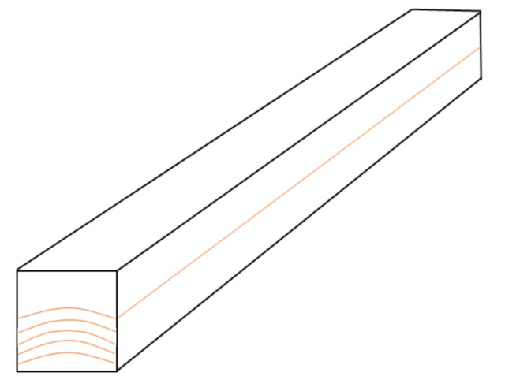
i.e. The rings are pretty square to the flat sides on the end (this makes things less complicated)
and the ring runs straight down the length of the wood.

You probably wont find one this perfect but on the nearest you find follow a ring right along both sides and make sure that when you have removed all the wood above this ring there will still be enough left to make the bow. Also make sure there is no major twist in it.

Also you don't want any knots or major imperfections in the wood
2. Buying some wood (cont)

When you have found one which looks good the next thing to check is the grain:

If you look closely to the top edge (as shown in the previous diagram) you can make out fine lines which run down the length of the wood.

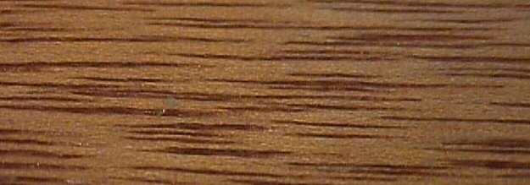
You need to check that these run parallel to the edge of the wood down its length and don't run off the side.
If they run off the side this is likely to cause the bow to snap, although I have found that on lighter bows at least you get away with this so its not so vital.

There is probably a lot more could be written on selecting a stave but I am no expert myself, the wood is cheap so buy some, give it a try and learn as you go is probably the best advice I can give here.
In my experience just looking for the above will narrow it down to 1 or 2 pieces anyway!

I find it best to go through all the wood pulling out any which look hopeful then go back through the resulting pile in the same way but in more detail etc. until you end up with just one left.


3. Making a start – Ring chasing

Note – I have recently made a self ash bow made with the stave turned 90 degrees so that the back and belly of the bow are the edge of the growth rings (90lb at 32”). It has a lot of chrysals so it looks like 80lb is prob. as high as you can go with this type of bow. It is far easier to make for a first bow as everything can be kept straight and square (see the laminate section for more info on this) and no ring chasing is required so you can skip this page.

First thing to do is decide which ring you are going to use.
Basically choose the ring closest to the top edge (as shown in the previous diagram) which is continuous the whole length of the stave - mark this with a pencil right round the stave
Make sure that the ring doesn't break through the top surface anywhere (as the rings are domed)

Now depending how much wood needs to be removed it may be worth removing some at the band saw (or handsaw for that matter) but its very easy to cut through your chosen ring so be very careful

What you should do now is skilfully using hand tools remove the wood down to your chosen growth ring (Chasing the ring), this is where the trusty angle grinder comes in:

Clamp your stave somewhere solid (e.g. A workmate) outside - do not try and do this indoors not even a shed as it creates massive amounts of very fine dust which goes everywhere
I find that if I do it on the lawn the dust just vanishes into the lawn no problem (but watch that the dust isn't blowing over the wall onto the neighbours washing as this causes upset ;-)
Make sure you have a good fine dust mask and eye protection and of course some very sturdy gloves.

Now using the angle grinder with a sanding disk fitted you can work your way along the stave simply rubbing away the unwanted wood – it really is that easy :-)
I go along first down to the ring above the one I want then go back and remove the final ring as this makes it less likely to go too far. I find that I can do the whole length in well under 1 hour.
See a video clip of this being done here - http://alanesq.com/ring-chasing.htm

Don't worry too much about getting it perfect as you can tidy it up with cabinet scrapers later on, just try and keep it as smooth as you can and try to remove as little of the ring you want to keep as possible.

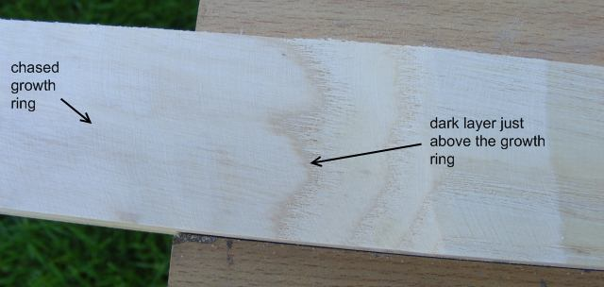
As you can see in this picture, you want to just remove the darker brown layer above the ring

That's all there is to “ring chasing”

Simples !!

4. Marking out the sides

Now you have your stave with chased ring its time to start marking out the bow shape:

First thing to do is mark a straight line down the chased ring which will be the centre of the bow
Do this by stretching a length of sting between the ends of the bow and drawing down it with a pencil (its important this is straight otherwise the bow string wont run down the centre of your bow)
If there are any small imperfections in the stave or if the grain doesn't run perfectly down the stave you can off set it a bit to try and correct this but make sure there will still be enough wood either side for the bow.

Now mark the centre of the line you have just drawn (i.e. The centre of the bow)

Now you need to mark out the width of the bow: this will depend a lot on what draw weight you are hoping to achieve (see bow dimensions section at end of this guide)
but basically you want to mark the handle width at the centre then a parallel line around 3 inches either side (so the handle section is nice and parallel sided)
then mark the tip widths at either end
finally join up these lines so you end up with something like this:
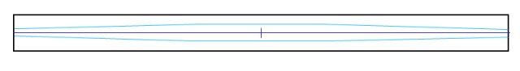

Now you need to cut this out, this is where a band saw comes in very handy although a hand saw or jigsaw could be used.
I have found a powered hand plane (can be bought for around £24) to be invaluable when making bows It can be a handy easy way of removing the larger part of the unwanted wood if you don't have a band saw and it gets everything nice and flat (hiding any wobbles in the cutting out ;-)

My advice is - don't try and get too close to the lines as you are very likely to go too far and ruin it, just cut it as close as you dare then use the angle grinder to finish it (much easier and no skill required ;-)

- try to keep the sides at right angles to the chased ring

5. Marking out the belly

This is different to marking out the width of the bow because the chased ring is very unlikely to be perfectly straight and so if you try and just draw a straight line the bows width will vary as the back of the bow goes up and down.
Note – on a laminate or 90 degree turned ash bow you can just draw straight lines here, as everything is nice and flat/straight

So what you do is get a sheet of paper which is 40inches long by at least 2” wide (I tape 2 sheets of newspaper together)
Draw a straight line for approx. 36 inches (half the length of your bow minus 3”)
along this line mark regular intervals (every 3 or 4 inches)
at one end mark up from this line the thickness you want the bow to be at the handle
the other end mark up the thickness you want the bow to be at the tip
then join these marks with another line

So you end up with something like this:
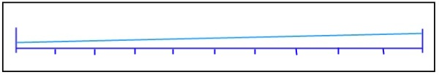
bow tip bow handle

Now the idea is to mark your bow with these same regular intervals then go along measuring what width the bow should be at that point (from the paper) and marking the width from the chased ring on the bow. When this is finished you join the dots and there you have your cut out line.

So on the side of your bow mark the centre. Then 3” either side (this will be the handle area so you want it to be a constant thickness)
From the paper (the right side in the above diagram) mark out the width on the side of the bow at the centre and these two 3” spaced marks you have just made and join the dots with a line.
I use some dividers to do this which makes the task easier (do this on both sides of the stave)

You then need to mark the regular intervals on the sides of your bow corresponding to the ones on your paper and go along each one measuring the width on the paper and copying this onto your bow.

So when you have finished you have a line down your bow with a constantly reducing thickness which follows the contours of the chased ring.
Something like this:
Now you can cut this out in the same manner as before – again I find it best to finish with the angle grinder (making sure your lines are followed on both sides of the bow)
6. Shaping the bow

You should now have something which is starting to look remarkably like a longbow :-)

Next you need to round all the edges:

The chased ring I just round the very edges using a cabinet scraper. Its very easy to do and doesn't take long. I think its important to do at this stage as a rounded edge is much less likely to split when you start bending the bow.

The belly also needs to be rounded but its debatable how round it should be. It is generally said that ash should not be given the more usual D shaped cross section as ash is not good at compression and this will concentrate the compression into a small area.
So its best to just round the edges and keep the central part flat in my opinion.

What I tend to do is go down each edge with the angle grinder trying to remove an even amount of the corner down the length of the bow then go down again with the angle grinder rounding it over, then use the cabinet scrapers to even it over into a nice rounded edge.
This gives a surprisingly professional looking end result :-)

Something like this:
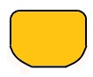
There is a school of thought which says that an ash bow should be completely square and I have made a 100lb bow that way but its very uncomfortable to shoot and doesn't look too good, also you may get complaints of it not being a real longbow etc..
I have made a 120lb self ash bow with the shape above it did eventually fail but only after many thousands of arrows were shot from it – even then I just removed the belly and glued some oak on so its still in use. I think 110lb is probably the highest weight you can really go with this type of bow (see later how to make heavier ones)

Now give the bow a good sanding to try and get rid of any rough parts as these may start a failure point when tillering (I have no proof of this but it seems like it makes sense?)
7. Temp nocks and string

Before you can put your bow on the tiller you will need some kind of nocks in the tips to put the string into.
I find a Dremmel type rotary tool handy for this but a hand file will do just as well, just takes longer. Best tool is a tile saw (looks like a hacksaw but the blade is like a file)

I have had several incidents where the string has come out this nock and launched the bow off the tiller so its important to make them good and deep to keep the string in place.
I tend to make a slot across the top and down the side of the bow tips but I suspect just slots down the side will do it if they are deep enough (and probably a better idea?).

I make 2 slots either end so I can easily use a stringer to string the bow later on

You will need a tillering string. This is just a normal bow string but longer
I like to have a loop at one end and the other end a bowyers knot so I can easily adjust its length.
If you don't make your own strings it may be easiest at this point to get one made for you

A good guide to making your own string can be found here:
http://www.tradgang.com/rob/ta/flemish

You want the string long enough so it can hang loose from the bow when its fitted for starters then tighten it up later as you get the bow bending.

8. Tillering

This is the dreaded part of making a bow, where all your hard work can become fire wood in an instant.
But, if you are careful not to rush and follow these instructions its not as bad as you may think.
I know people say you should first bend the bow in the vice or by hand a bit to get it started but I find this just confuses me and its simpler just to get it on the tiller as you can then watch what's happening from a distance.

First you need to make yourself a tiller, there are several types including a simple hand held one for light bows, but I would recommend you take some time to make yourself something decent (and strong) as the last thing you want when trying to make your bow is to have to struggle to draw it and see what is going etc.

There are several designs of tiller but the easiest and best in my opinion is to bolt one to a wall.
See more details here – http://www.alanesq.com/tiller.htm

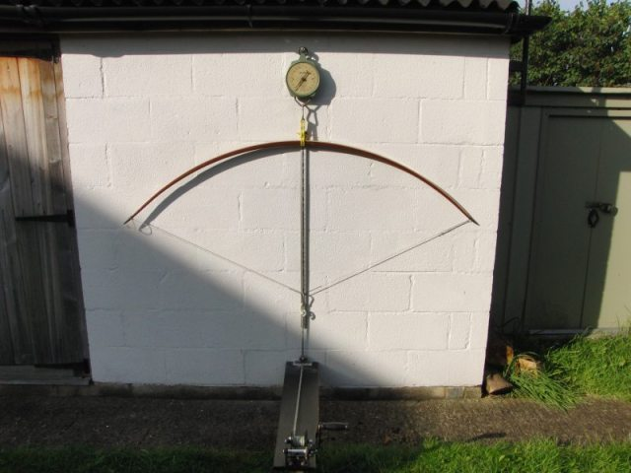

8. Tillering (cont)

Put the bow string on your bow but have it loose (i.e. The bow is not braced at all)
sit the bow on the tiller with the centre of the bow at the centre of the tiller
attach the string to the rope of your tiller (I use a carabina for this)
loop the rope through the pulley and stand back taking up the slack
make sure the bow is sitting flat by adjusting where the rope attaches to the bow string.

Note – its a good idea to have some scales fitted between the bow string and the tiller rope so you can keep an eye on what amount of weight you are putting on the bow. It is said you should never put more weight on the bow whilst tillering than the final goal draw weight of the bow.

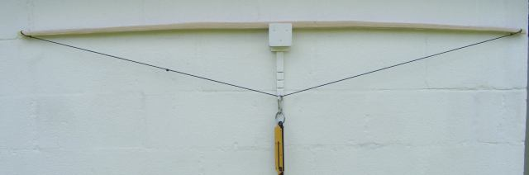
Now just start to put a bit of pull on the rope, just enough to get the bow to flex the slightest amount and watch what happens to the bow.
Release and do this again many times until you get an idea of how the bow is bending.

What you ideally want is the bow to bend evenly over its entire length so if you are happy its doing this then you can try pulling slightly harder
Most times I find that even when I have got up to full draw weight the bow has not flexed the slightest amount so I have made it far too big and I have to start removing a lot of wood.

I use my angle grinder and try and go down the length of the bow evenly so not to distort its shape but if you have to remove a lot of wood you may find this doesn't happen and you have to go back to marking out the bows thickness.
Whenever I have removed wood with the angle grinder I then tidy it up with cabinet scrapers and a quick sanding before going back to the tiller

If you are lucky the bow will look like its starting to bend reasonably and the tillering can start for real:

Basically you just keep slowly increasing how far you pull the bow keeping a very close eye on how its bending.
Don't forget to compare the two limbs and try and get them bending the same

8. Tillering (cont)

You are looking for the finished bow to form a perfect segment of a circle
which basically translates as the amount the bow bends is constant down its entire length

Sometimes it can help to actually draw a circle on the photo of your bow:
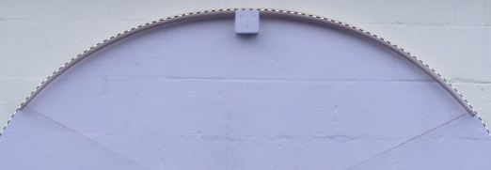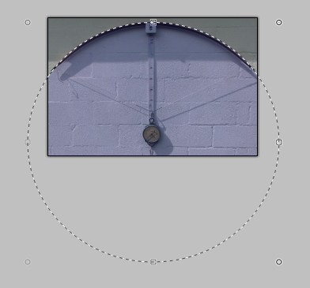
You can then easily see if your bow is bending too much or too little at any point
If the centre of the circle is off centre to the bow then you know the limbs don't match

Flipping the image left to right can also help you to see any problems
- a great free program for manipulating images on a P.C. is www.getpaint.net
If you use this program to draw an oval which best fits your bow, if the oval is taller than wide then this suggests the limbs are too stiff. If the oval is wider than tall then the handle area is too stiff.

When looking at your bow on the tiller try and look at small sections of the bow and compare the bend to other sections, they should all be bending the same amount (its not easy and studying photos is the best way)

Always keep an eye out for any part of the bow which seems to be bending too much (a hinge)
as these are the big danger when tillering, a slight one will rapidly become a very big one if you pull the bow a bit further and then the bow is ruined.
If you see one you have to remove wood from other parts of the bow but leave that spot well alone.

You are also looking for parts of the bow which are not bending and remove wood from these areas
-just a quick rub with the angle grinder, tidy up with cabinet scraper, quick sand then back on the tiller.

Its a bit of a balancing act but as long as you don't curcum to the temptation to just pull the bow a bit more to see what happens when you are not happy with it where it is then you will be OK
Just keep putting it back on the tiller and making small adjustments and never rush!

If at any time you are not sure, take a picture of the bow and go study the picture indoors.
Even post the picture on forums for advice.

Note – always mark on the bow with a pencil where needs adjusting whilst its on the tiller to make sure you don't end up getting mixed up and adjusting the wrong part. I tend to write a “H” anywhere I think there is a hinge developing (and I then know not to remove any wood from near this) and a “S” anywhere which I think is a bit stiff (the bigger or more times its written the more wood needs to be removed) - Then erase this mark when you have done the adjustment
8. Tillering (cont)

A simple tool can be made which can help with seeing any inconsistencies in the bows tiller. If this is run along the bow whilst it is on the tiller the indicator should not move up or down (The more it moves up, the more the bow is bending)
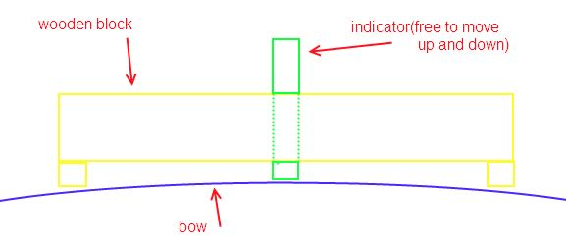

Once the bow is bending enough you can string the bow properly (start with a low brace height and increase it as you go until its eventually fully braced)

As you may be realising by now, its a bit of an art form and not something you can explain easily (as I am now realising myself)
but take your time, ask advice on forums as you go and you will get there :-)

I found it really useful to study as many pictures of bows on the tiller I could find until you start being able to spot problems etc.. Forums are good for this.

Of course another complication is that you will be aiming for a particular draw weight. The trick to this is to keep an eye on the scales as you tiller and never pull it harder than your target draw weight. If you get to this weight and the bow is still not fully drawn then you need to remove a small amount of wood from the entire length of the bow then put it on the tiller and try again etc. etc.

The important thing is never pull the bow harder until you are confident that the shape of the bow is as perfect as you can get it as it is
Keep a keen eye out for any weak spots (i.e. Where it bends more than it should) and take your time

as soon as you feel yourself losing patience or rushing stop and have a break

This can all seem very daunting and I found the more I read on the subject the harder the task seemed. The trick is to not worry about it, just jump in and have a go. Don't be afraid of failing as you will learn more through an afternoons failed try at making a bow than a month of studying books on the subject.

9. Finishing

Now your bow is tillered there are a few other things you will need to do to finish it:

You will want to put a bowyers mark on the side of the bow so you know where the arrow should be shot from. Make this approx. 1” above the centre of the bow.
You can also mark what the draw weight etc. of the bow is but I find I tend to modify it later or it changes on its own so its easier not to bother.

You may want to make some nocks for the bow tips although I have used self nocks (i.e. Just slots cut in the wood) on these bows even up to 120lb no problem
If you want to make horn type nocks then I find Acetal engineering polymer works very well (search eBay for acetal rod)

You need to seal the wood with something to keep moisture out. I just use a good few coats of water based varnish on mine but there are lots of different finishes you can use.
Ash is very good at taking on moisture so its important to have a good finish on it

You will want to measure how much string follow it has (if just because everyone will ask you this)
I measure it by holding the bow tips against a wall and measuring the gap between the wall and the bow at the handle (do this when the bow has not been braced for several hours)

Varnish news  I can't thank Gavin Banks enough for putting me on to this fantastic varnish for both arrows and bows:  Its actually Clear Lacquer from Halfords and costs around £7 for a large spray can  The great thing with this stuff is being a spray it couldn't be easier to apply, it brings the colour of the wood out great and best of all it dries VERY quickly.  I find one good coat of this, 5 mins dry time and jobs a good un ! | 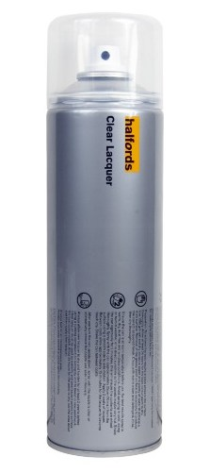

Now its time to start using it
It is best to slowly build up to full draw over a few dozen arrows (shooting the bow in)
this is kinder to the bow and I am told will result in a much better bow

Shooting arrows from a bow you have made yourself for the first time

makes all the past hard work worthwhile.

enjoy :-)
10. Misc adnl tillering info

-Its also a good idea to exercise the bow as you go - i.e. Pull it and release it 20 or 30 times
This amongst other things helps make sure the bow isn't going to suddenly lose a lot of draw weight
This can be quiet dramatic; my 100lb bow was around 100lb at 28 inch as I was tillering it but then I took it up to 32” and it ended up 100lb at 32” (I believe this happened because I had not exercised the bow enough as I went ?)

-Its very easy to remove too much wood at a stiff point and end up with it bending too much (a hinge) which can rapidly grow out of control. So always only remove small amounts of wood at a time and take back to the tiller to see how it looks
As is often said; you can always remove more wood but you cant put it back on!
-If you do see a hinge forming you need to remove wood from everywhere apart from where the hinge is to bring the bow back into balance.

-Bows tend to lose a bit of draw weight when you start using them so try and make the bow a bit heavier than you want it to be.
If you make the bow on the long side you can always shorten it later on to increase the draw weight a bit.

-String follow: This is something which people talk about a lot (i.e. How bent the bow is when the string is removed)
A bow will always “follow the string” a bit but on a Medieval type bow the whole bow is bending its going to be more than a Victorian type bow (where only parts of the limbs bend) so I don't worry about it too much
for a 78” bow anything under 3” is good
but don't forget it also depends how much bend the bow had before you even started tillering it

-Ash tends to fail under compression which will result in fine cracks running across the belly of the bow (chrysals)
so its especially important not to allow and hinges to form whilst tillering as this can quickly cause the wood to crack.

-If you plot a graph of a longbows draw weight compared to draw length it is a surprisingly straight line, so you can easily predict what a bows draw weight is heading for.
e.g. If a bow is 50lb at 28” and 60lb at 30” then it will be 70lb at 32” (assuming you don't remove any more wood)
although expect your bow to lose a bit of weight when you start using it so always aim high.

-Whilst tillering your bow its worth occasionally looking down its length to check it still looks a good shape for a bow (i.e. No lumps or dips and it tapers nicely etc.)
Another thing to look for which is a sign your bow is well tillered (although not a perfect way as it also depends on how consistent the rings in your stave are etc.) is that when you look at the belly of your bow the growth rings should (in an ideal world) be the same either end

Something like this:
11. Bow Dimensions

How to decide what dimensions to make your bow:

There can be very surprising differences in the strength of two seemingly identical staves so this is always going to be a bit of an educated guess, but these are the dimensions of some of the bows I have made to give you a starting point (all are kiln dried American Ash).

45lb at 28”
Width at handle = 30mm
Width at tips = 15mm
Thickness at handle = 20mm
Thickness at tip = 15mm
bow length = 1.9m
This bow is very square in cross section

100lb at 32”
Width at handle = 36mm
Width at tips = 15mm
Thickness at handle = 25mm
Thickness at tip = 15mm
bow length = 1.95m
This bow is very square in cross section

120lb at 32”
Width at handle = 38mm
Width at tips = 18mm
Thickness at handle = 28mm
Thickness at tip = 18mm
bow length = 2m
This bow is semi rounded (as the previous diagram)

90lb at 32” (90 degree turned stave – i.e. edge of growth rings on back/belly of bow)
Width at handle = 29mm
Width at tips = 12mm
Thickness at handle = 23mm
Thickness at tip = 14mm
bow length = 78”
This bow is pretty square in cross section

Notes:

The wider you make the bow compared to depth the less compression the belly will have to take so always safest to make ash bows on the wide side

Width has much less effect on draw weight than thickness (front to back), if you double the width you double the draw weight but double the thickness and its eight times the draw weight.

I have found that 110lb at 32” is about the highest draw weight you can get out of this ash

12. Making heavier than 110lb at 32” bows

I really struggled for some time trying to make myself a 130lb bow as anything over 120lb failed on the tiller with bad chrysals
(the bows didn't snap but the chrysals were going very deep through the bow and I didn't dare try to shoot them)
These Ash bows are fine up to around 110lb when its just asking too much of this ash. The back is fine but the belly just cant take the compression.

The obvious answer was to get some better wood. I was considering importing some Osage but there is not much about and I had great difficulty finding anything other than ash locally (certainly nothing cheap)
I then did a lot of experimenting with heat treating the ash and I thought at first I was on to something but later came to the conclusion it wasn't helping.

I eventually tried removing the belly of one of these failed bows - I did this by chasing a ring on the belly side, leaving 5 growth rings the length of the bow (with my trusty angle grinder this was a simple task)
I then used a belt sander to get this as flat as I possibly could (I think a surface sander would be much better if you can get access to one)

I then glued it to a length of 2” x 1” oak using Polymite glue, just straight onto the planed surface of the oak as it came and then cut round the ash and made a bow (I had chosen a bit of oak where the grain and rings ran pretty straight)

The result was astounding; a 160lb at 32” bow (this is the picture on the front page of this guide)
I got this bow down to 140lb by retillering and lengthening slightly when I added the nocks (as this is the draw weight I want) but it had no problem at all being 160lb

Update: The bow was great until after a few months the oak suddenly started to chrysal, I don't know why as until then it had worked great – I later replaced the oak with lemonwood and this worked very well and is very easy to work with. This bow is still in use to this day (jan10)

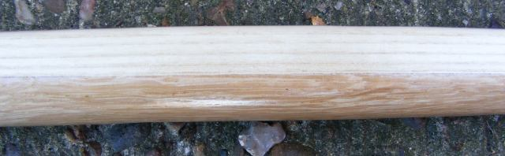
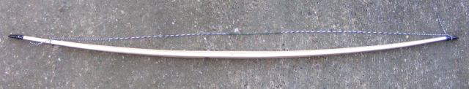
13. Laminates

Another way to get a heavier bow is to make a laminate bow
I had not really wanted to go this route as I like self bows (but with my oak/ash bow I guess I had already given up on this idea anyway?), I was desperate for a new bow but unable to find any suitable ash so I had a try at making a laminate bow.

BTW – This was a lesson I learned here, always have some wood in store ready for your next bow, as you can be sure when you most need it you wont be able to find any

I have found that bowyers are often willing to sell you strips of wood to make laminate bows from. Hickory is about the best wood for the back (although ash with a chased ring should be very good). Ipe I have been very impressed with as a belly although its not that easy to find. The strip in the middle is to help the belly cope with the compression as it has more give in it.

I again used the Polymite glue which is cheap, readily available, easy to use and amazingly strong
I bought the wood already cut in strips so it was just a matter of gluing them together (the best way to clamp them whilst the glue sets is to tightly wrap some rubber strip around it (e.g. strips cut from an old inner tube)
Its a good idea to run down them with a power plane first on either side to make sure they are flat
Use plenty of glue and expect to make a lot of mess, but its not a difficult task

Of course the idea is to keep the lines of glue very thin but mine have opened almost 1mm in places but this has not caused any problem

It is important that its not too cold otherwise the glue wont set – I glue it up in my workshop then after an hour or so when the glue has solidified I move it into my house for at least 24hrs to set.

You will find that marking and cutting out the stave is easier than a self bow as everything is nice and straight/square but apart from this its very much the same technique to make a bow from it.

Another difference I found was that Hickory is not as tough as Ash so whilst tillering the string was tending to damage the bow tips (and broke a chunk off at one point)
so for heavy bows (i.e. over 100lb) it may be a good idea to fit the “horn” nocks before tillering?

13. Laminates (Cont.)

The bow I have made is Hickory, Purpleheart and IPE
it is 135lb at 32”, 82” between nocks (too long but I want to be able to shorten it later to up the weight) and at the handle it is only 30mm wide by 28mm (tips 18mm x 18mm)

As I discovered, IPE has a tendency to twist so its important to keep an eye on this as you tiller, this is not something I have had to even consider on my other bows.
I suspect making the bow on the wide side may help stop this and make sure the bow can't twist whilst on the tiller by keeping the handle nice and square until the end (this is where I think I went wrong)

It is vital to have your bandsaw set up correctly with a decent blade or you can really struggle cutting the bow out – watch the dust though as it's very nasty stuff, do not breath the dust at all, I found even getting it on your skin can sting !

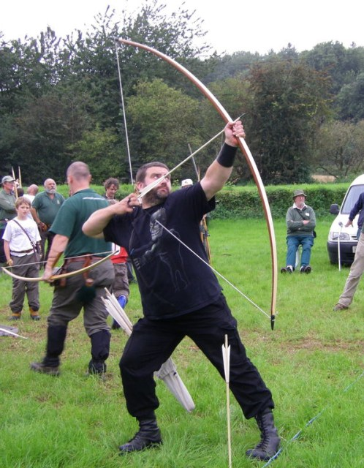
I am very pleased with this bow, it performs very well, cost under £40 and I soon broke my distance record with it

13. Laminates

I have developed a new technique for making laminate bows which whilst (as you probably already suspect) totally unconventional it makes the task very much easier especially for a beginner.
Note – this is not really suitable for self bows as they tend not to be straight

Once you have a roughly cut out bow from your laminate stave the magic tool this time is a hand held power plane. These can be bought for around £25
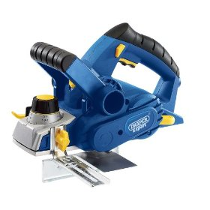
Have it set to take a thin cut and go down each side of the bow to get things nice and flat and a good overall look/shape. Then do the same with the belly of the bow
This results in the sides and belly of the bow being perfectly flat and half the battle is won
Now round off the edges of the back of the bow (probably Hickory or Ash) with a cabinet scraper or sandpaper

What I do then is run a router with round over bit along the belly of the bow, this saves a lot of work getting the belly shaped
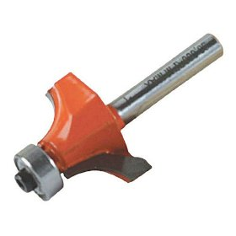
This gives a nice even rounded edge to the belly but keeps the centre flat. This I prefer anyway as I think it gives the belly a better chance of surviving the compression on a heavy bow

Once you have completed the above you will be surprised how quickly and easily you have ended up with a professional looking bow :-)

Now just the tillering to do
Because the planer has ensured everything is nice and flat you will find this easier than a self bow.
As the belly is flat I just use the power planer to make adjustments (instead of the usual rasp and scraper) this is very quick and easy to do. I just place the bow on the lawn belly side up and go down it with the planer (or belt sander for finer adjustments) – sounds like a stupid idea but actually works really well.
If I end up having to remove a lot of wood I may run it through the router again to get the edges rounded again.

Using the above technique, making a bow is very quick and simple
apart from the time required in getting the tiller right it couldn't be a simpler task
13. Laminates

I would imagine you could cut the bow out with a jigsaw if you don't have a bandsaw (you don't have to be mega accurate as you can neaten everything up with the planer easy enough), as long as you don't go the wrong side of the cutting line

BTW – I have a vacuum cleaner which doubles as a dust extractor on the power plane which makes the job very much cleaner and less messy – well worth getting one

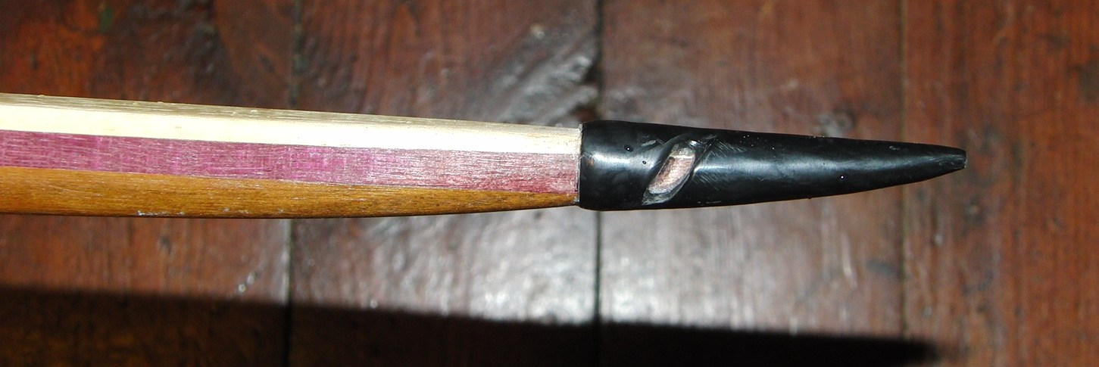
14. Repairs

Chrysals
If your bow gets a chrysal all is not lost. If its very small then you can just keep an eye on it and check it is stable (i.e. isn't getting worse over time). I have used a bow for many thousands of arrows which was covered in shallow chrysals although they did eventually grow and kill the bow.
You can also re tiller the bow to try and get it bending more in other places along the limb to try and take some of the pressure of the chrysal

If the chrysal is getting worse or if its deep then there is still the option to cut out the failed wood and replace it
I have thrown away a couple of bows which I now suspect I could have saved in this way.

I have recently done this on my ash/oak bow (as I messed up the above and ended up making the chrysal much worse)
I cut out a rounded segment and then cut a piece of wood to fit and glued it in using Polymite glue (this really is impressive glue!), gave it a day to set then reshaped it to match the rest of the bow

This technique I am told can have a tendency to pop out resulting in an exploding bow
I have since been told that I should have made this a lot longer (i.e. 6” either side) although I have now done 2 repairs of aprox 4” length and they are working no problem on a 130lb bow.
BTW – Its an interesting thought that the above could also be used to repair a bad hinge on a bow ?

I have found the best technique is to use the angle grinder to remove the wood and roughly shape it how you want then use the end of a belt sander to finish the hole and make the edges nice and parallel (this makes shaping the insert much easier)
I then hold a block of wood at the side of this hole and draw along it with a pencil
If you are careful to follow this line on the band saw it can be a surprisingly good fit.
Sand the plug to shape, to make it as good a fit as you can then glue it in, leave it 24hrs, shape it to match the bow, check it on the tiller and the jobs a good un :-)
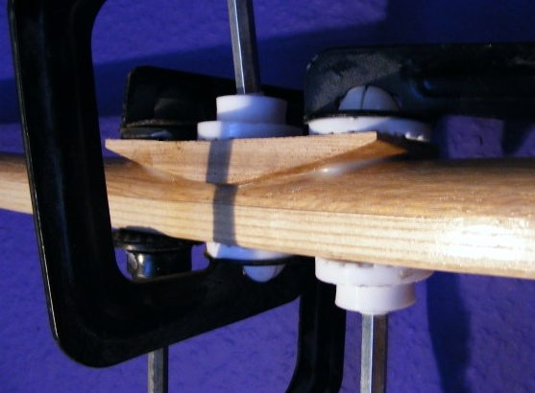
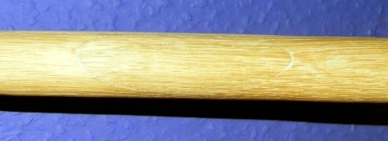
15. Links

Some links to more help/info on bow building

If you want to buy a ready glue laminate stave (or a very good value ready made bow) then I highly recommend Irondale
http://www.irondale-longbows.com/

AIUK bow making forum
http://www.archery-interchange.net/

Derek Hutchinson's web page – lots of great info on making bows
http://sites.google.com/site/delsbows/home and http://www.bowyersdiary.blogspot.com/

If you are interested in warbows then consider joining the EWBS for lots of help/advice
http://www.englishwarbowsociety.com/

Bow building guides
http://poorfolkbows.com/

